Side Lying Reach and Roll

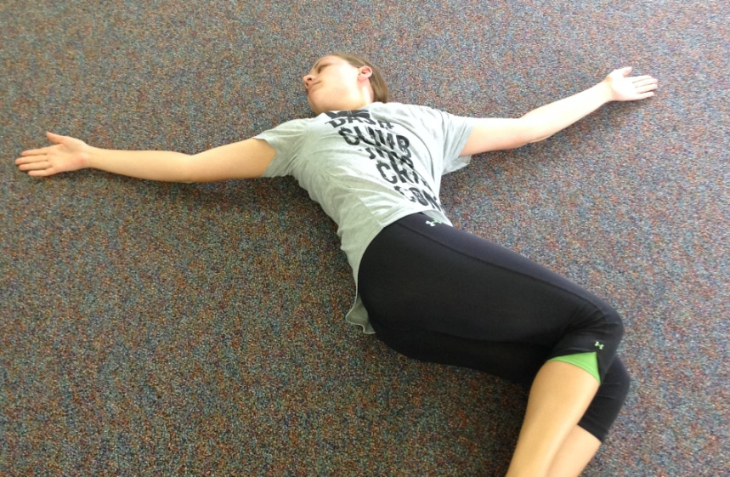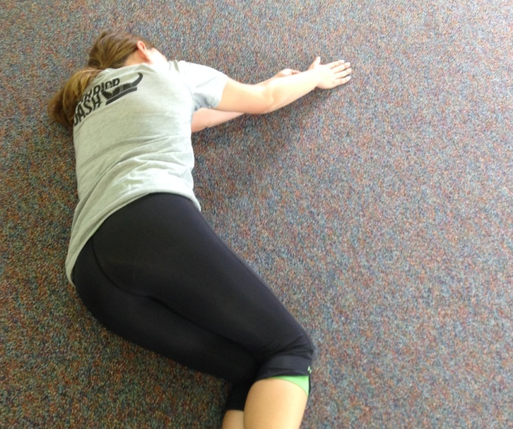

1. Lie on your left side with both hands out in front of you. Bend knees with one leg on top of the other.

2. Lift your right arm and move it across your body, keeping your eyes focused on the right hand. Keep your knees from lifting

3. You may feel a stretch in your neck, shoulder, pecs, rib cage, and through the spine.

4. Return to starting position and repeat 5-10 times on each side.