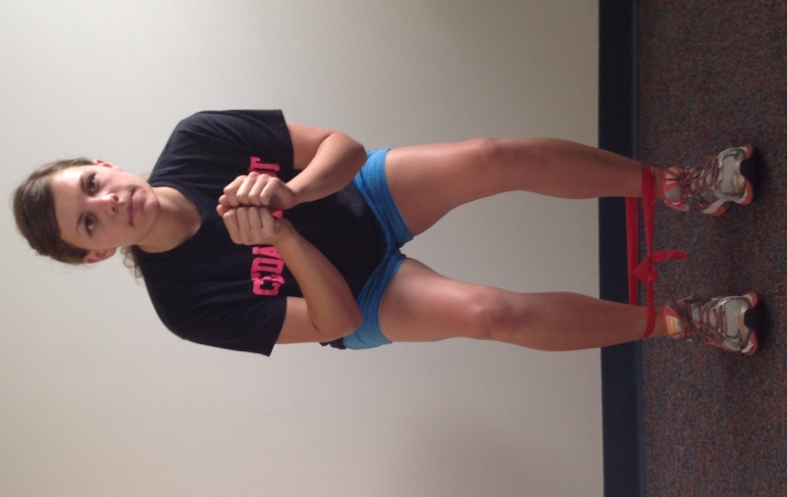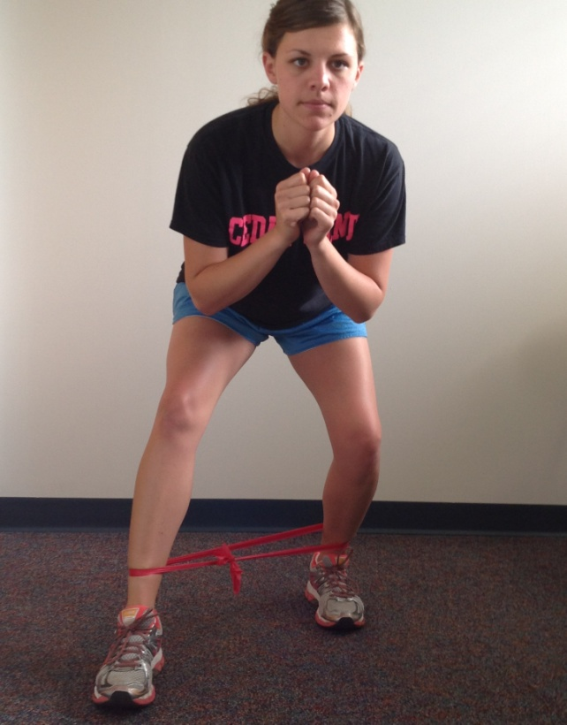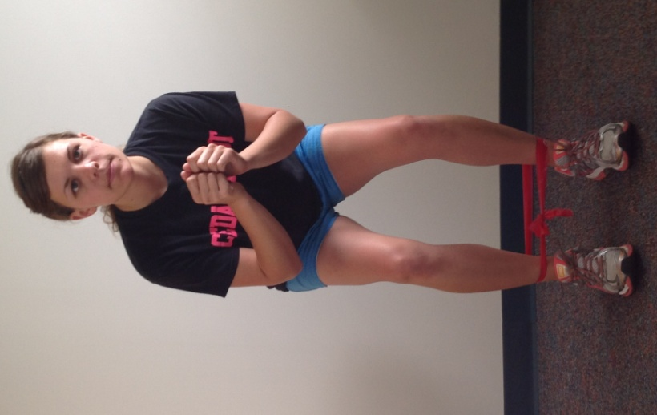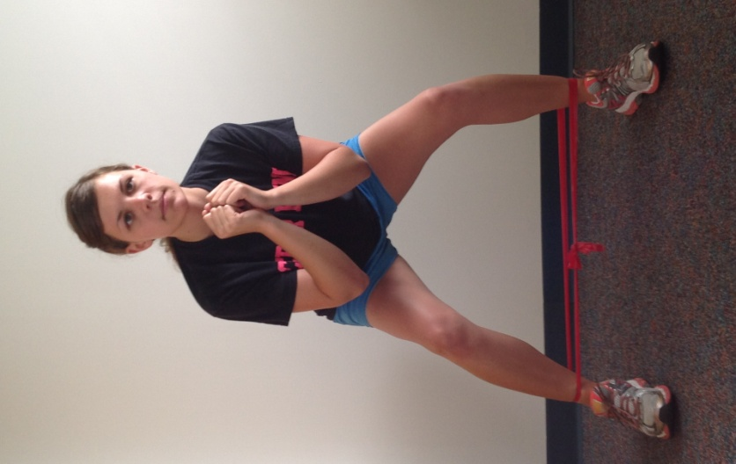

**TB Speed Skater**

With the band around your ankles get into a squat position. Start with feet hip width apart. Walk forward bringing the foot out at a 45° angle. Alternate feet, bringing them back to the starting position before each step.

**TB Side Step**

With the band around your ankles get into a squat position. Proceed to side stepping, keeping tension in the band at all times. Keep knees and toes pointing straight ahead, knees behind toes and butt down.

**TB Side Step and Speed Skater**